**Caerphilly North Neighbourhood Policing Team**

**Bargoed Wards Monthly Update.**

**September 25’**

**Report for September Meeting**

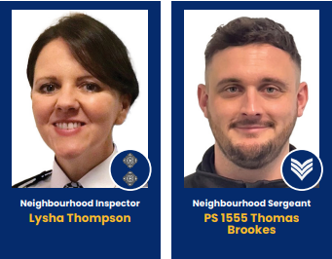

**Bargoed Neighbourhood Team**

**Recorded Crime**

|  |  |  |  |
| --- | --- | --- | --- |
| Ward | July 25’ | August 25’ | +/- |
| **Bargoed** | 70 | 66 | -4 |
| **Aberbargoed** | 58 | 63 | +5 |
| **Pengam** | 15 | 18 | +3 |
| **Gilfach** | 10 | 17 | +7 |
| **Total** | **153** | **164** | **+11** |

The Bargoed Section has experienced an overall ***increase*** in crime between July & August.

**Recorded ASB (Nuisance/Environmental/Personal)**

|  |  |  |  |
| --- | --- | --- | --- |
| Ward | July 25’ | August 25’ | +/- |
| **Bargoed** | 10 | 5 | -5 |
| **Aberbargoed** | 7 | 6 | -1 |
| **Pengam** | 4 | 3 | -1 |
| **Gilfach** | 1 | 0 | -1 |
| **Total** | **22** | **14** | **-8** |

The Bargoed Section has experienced a slight ***decrease*** in ASB between July & August.

**Community concerns or patterns to note.**

Following reports of person(s) drinking alcohol/drug dealing and being a general nuisance in the Aberbargoed area, PCSOs have increased their patrols and spoken with residents over the last few weeks in attempts to try and deter the behaviour and establish those responsible.

Over the summer months the team received increased reports of vehicle crime in the Aberbargoed area. Due to this, PCSOs have again increased their patrols in attempts to deter this behaviour & deal with those responsible. The Community Action Team (CAT) is also due to be deployed in the Aberbargoed area to assist with the increase of crime in this area.

Due to an increase of complaints regarding noise and dangerous driving in the Bowen Industrial Estate, our Crime and Reduction Officer (CADRO) has been liaising with environmental health. Letters have been distributed to the businesses on the estate and our traffic unit have been made aware to provide extra support in the area.

**Targeted Activity**

**Go Safe**

Following concerns from residents and as part of ASB week, on the 2nd July officers teamed up with Go Safe for Operation ATAL outside Heolddu Comprehensive School to tackle speeding outside of the school. We monitored 96 cars, 19 were educated for exceeding the speed limit, 2 drivers were educated for not having their seat belts on and one TOR (Traffic Offence Report) issued for no insurance.

**Vehicles**

In July, after a report from a member of the public, an abandoned vehicle which was badly damaged was recovered from the Aberbargoed area due to being suspected stolen.

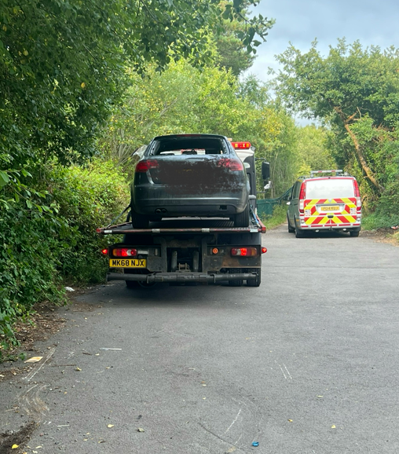

**In other news..**

As part of the ongoing Clear Hold Build project, on Thursday 21st August, Bargoed NPT assisted our colleagues in the Rhymney NPT, investigating the supply of Class A drugs in the area, carried out 3 early morning warrants across the Moriah ward. A large quantity of cash, cocaine and cannabis was seized along with 2 off-road bikes, 2 cars, mobile phones and a laptop. A 25-year-old male was arrested and later released on bail while the investigation is on-going.

On 29th August officers from Caerphilly North NPT also carried out a warrant at a property in the New Tredegar area. During the operation approx. 80 cannabis plants were discovered and seized, along with a vehicle believed to be connected to the address.

Whilst these warrants took place in Rhymney the disruption of this activity has a wider impact on the Upper Rhymney Valley with the drugs and criminality having a wider impact.

**These investigations remain live at this time.**

**Engaged Communities**

Officers have enjoyed a busy summer hosting and attending events throughout our Bargoed wards - from attending a Heddlu Bach pass out parade, to taking the gaming van to a dinosaur event in Bargoed. Neighbourhood ward managers have attended Aberbargoed Primary School for a munch and move event and have given an anti-social behaviour input to the children. The neighbourhood team have also been busy attending many fetes, community fun-days and great summer projects organised by partners throughout August!

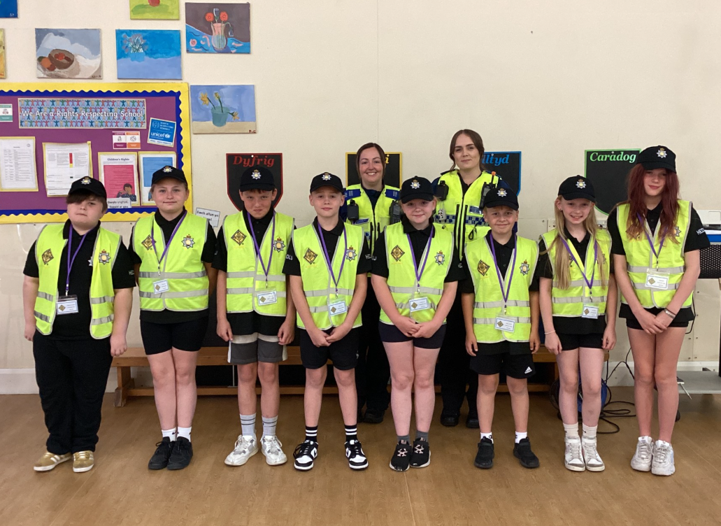

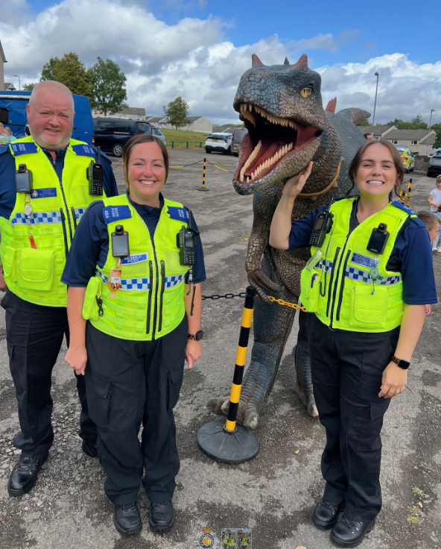

**Upcoming Police Surgeries:**

Bargoed – Morrison’s

* Tuesday 23rd September 14:00 – 14:30
* Sunday 5th October 14:00 – 14:30
* Tuesday 14th October 14:00 – 14:30

Aberbargoed – Library

* Tuesday 30th September 17:00 - 17:30
* Tuesday 21st October 17:00 - 17:30
* Tuesday 18th November 17:00 - 17:30

**Thank-you for your continued support - Caerphilly North Neighbourhood Team**