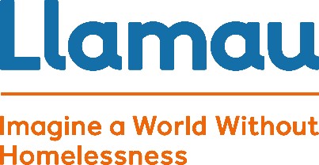Sarah Huish

Project Manager – Caerphilly

[SarahHuish@llamau.org.uk](mailto:SarahHuish@llamau.org.uk)

t 01443879574

m 07966 981107

Dear Bargoed Parish Council,

I'm writing to you from Llamau: the leading Welsh charity that believes in ending homelessness. Last year, we helped over 460 young people, women and children across Caerphilly Borough County to not just survive, but thrive and build resilient, independent futures.

Our work impacts not only the people we support but also the broader community. By comprehensively supporting vulnerable people, including through early intervention and prevention, we reduce the pressure on families and public services. This builds toward our ultimate goal of creating a Wales without homelessness.

At the Park Villas (24 Hour Staffed) project in Bargoed we’ve supported 14young people in the last year, whilst a further 10 young persons have been supported in our 5 Bed unstaffed Project In Bargoed.

We’re already at maximum capacity at our projects and know even more people need our help. With drastically reduced government funding and the stark cost of living, we just don’t have the resources to help everyone right now.

So, we’ve decided to be proactive and come to you – our community – for help. Llamau needs to raise funds to grow, improve, and continue to deliver our life-changing support to every young person facing homelessness in Bargoed.

If you want to support the most vulnerable people in your area at Christmas, so that we can ensure that every young person has a Christmas dinner and a present this Christmas then please contact us using the details heading this letter. We’re eager to hear from you and together, create a Christmas to remember for our young people.

Yours Sincerely

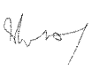

Sarah Huish

Project Manager- Park Villas + Cardiff Road Bargoed