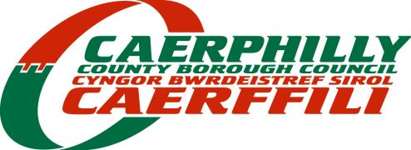
Directorate of Communities

HANBURY ROAD & HIGH STREET, BARGOED

TEMPORARY PROHIBITION OF DRIVING AND WAITING
FRIDAY 12 – SATURDAY 13 MAY 2023

On behalf of Caerphilly County Borough Council I give notice under Section 16a of the Road Traffic Regulation Act 1984 of the following temporary road closure, no one shall cause any vehicle to proceed in the roads described below:

DURATION Hanbury Square leading to High Street/Upper High Street from its junctions with Wood Street and West Street will be closed from 21:00 on Friday 12 until 21:00 on Saturday 13 May 2023

1-No waiting will also be applied to the corners of Wood Street, Henry Street and Ruth Street route for the bus diversion from 9 pm on Friday 12th and until the roads reopen at 21:00 on Saturday 13 May

2-No waiting will also be applied in all loading bays through High Street, Hanbury Road and Upper High Street for the same period

REASON To accommodate the Bargoed May Fair as a ‘special event’ on the highway

DIVERSION Wood Street, Ruth Street, Henry Street, Heolddu Road, Church Place, Bristol Terrace

ACCESS Emergency service, pedestrian and event maintenance access will be maintained

INFORMATION More information can be obtained from Caerphilly County Borough Council on 01443 815588 or events@caerphilly.gov.uk

Signed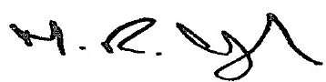_
Head of Infrastructure

29/03/2023

TM/23/804/AV

