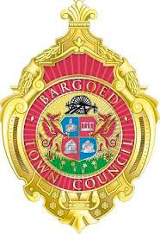
Bargoed Town Council

POLICY & RESOURCES COMMITTEE
MEMBERSHIP AND TERMS OF REFERENCE

- Functions/Responsibilities
- To consider issues affecting policies of the Town Council.
- To revise existing Council policies and to devise new policies as and when required.
- To consider aspects of management of resources including the consideration of budget monitoring reports and the preparation of the draft annual budget.
- To review financial regulations and to undertake an annual risk assessment review.
- To be responsible for all personnel matters affecting the Council.
- To make recommendations to the full Council.

- Membership
- The Committee shall be re-appointed at the Annual meeting of the Town Council.
- Eight Members of the Council shall be members of the Committee.
- The Deputy Mayor of the Council shall be appointed at annual meeting as chairman of the Committee.

- Quorum
- No business may be transacted at a meeting unless at least 3 Members of the Committee are present.
- Standing Orders
- The Town Council’s Standing Orders will apply to all meetings of the Committee.
- In accordance with Standing Order 7 this Committee has full delegated powers and reports to full council.
- Meetings
- Meetings will take place a minimum of 3 occasions each year (extra meetings will be held as necessary).
- The Code of Conduct adopted by Council shall apply to Councillors in respect of the entire meeting.

