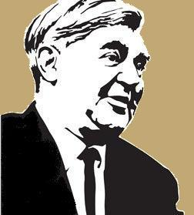
October 2020

Breast Services

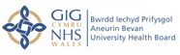

Development of a Unified Breast Unit

As part of its strategic plans, the Health Board remains committed to the development of a unified Breast Cancer Service on the Ysbyty Ystrad Fawr site and BAM Construction Services Ltd have been selected to develop the proposed new unit at a total cost of circa £10m, BAM are the original company that built Ysbyty Ystrad Fawr. A Project Team has been established to oversee the development of the new unit on the site and an Outline Business Case has been submitted to the Welsh Government for consideration.

A Breast Reference Group has been established to facilitate stakeholder input into these plans and will continue to work with the Health Board to ensure a patient focus approach to the design, environment and flow of the new unit. If you would like to join the Breast Reference Group or require further information please contact Mrs Michelle Oram on 01633 656348 or email Michelle.Oram@wales.nhs.uk

Could You Help Us Raise Money For The New Breast Unit?

A fundraising campaign has been established to enhance the interior of the unit. The Friends of ABUHB (Aneurin Bevan University Health Board) Breast Unit was set up in 2018 with the aim of raising £200k towards the new unit, which is due to open at Ysbyty Ystrad Fawr in late 2021. The group aims to raise funds for the additional facilities the NHS is unable to provide. The volunteers in the group have all had their lives affected in some way by breast cancer.

Any fundraising activity you undertake will help
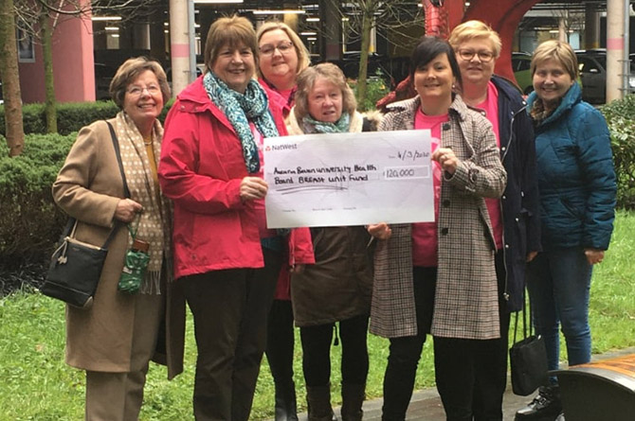
ensure the best possible environment for local
people affected by breast cancer, providing a
warm and welcoming environment for patients
and their families.

We need your help:-

- Organise a fundraising event.
- Help us spread the word and encourage others to get involved with our fundraising.
- Take part in an ABUHB charity fundraising event.

If you are interested in finding out more please contact Emma Wilkins: Emma.wilkins5@wales.nhs.uk

