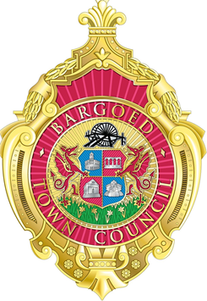
BARGOED TOWN COUNCIL
Mrs Helen Williams
Town Clerk
The Town Hall
Bargoed Police Station
Hanbury Road
Bargoed
CF81 8XF

Tel : 01443 830184
E-mail : bargoedtc@btinternet.com
Visit us at: bargoedtc.org.uk
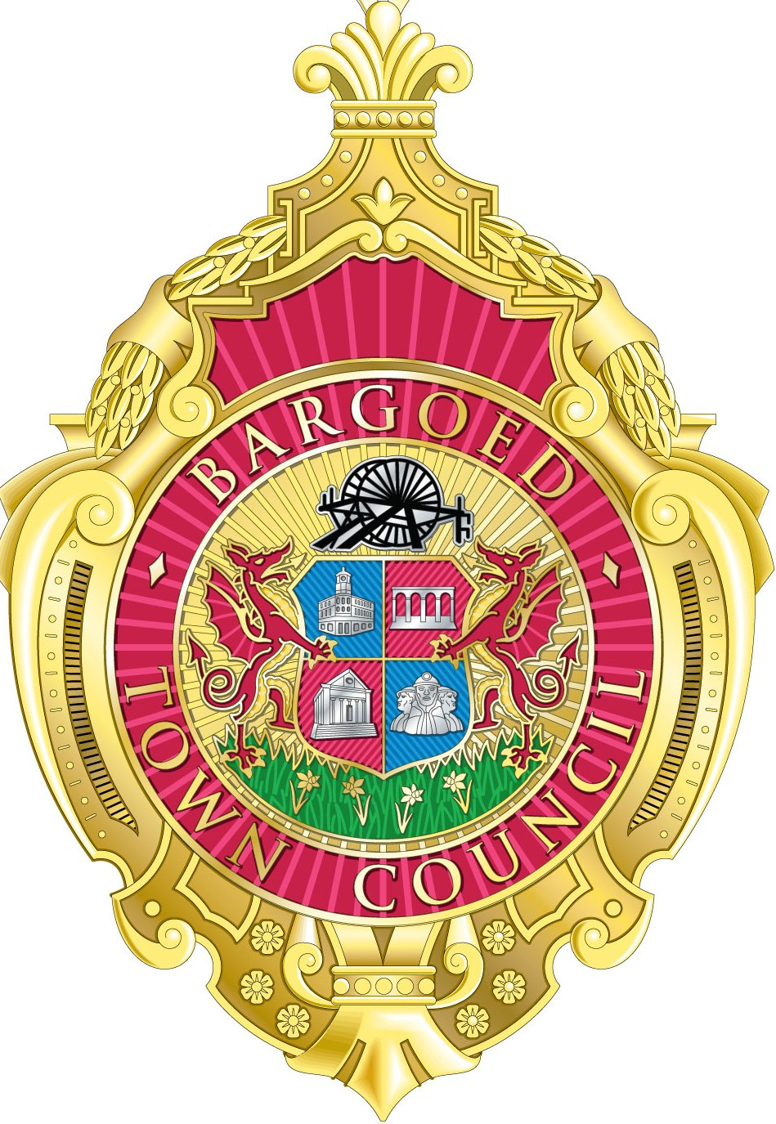

To the Mayor and Members of
Bargoed Town Council.

20th March 2019

Dear Councillor,

The next meeting of the council will be held at 6.00pm on Wednesday 27th March 2019 at the Town Hall.

Yours faithfully,

H S Williams

Helen Williams
Town Clerk,
for and on behalf of the Mayor.

A G E N D A

1. | To receive apologies.
2.  3. | Declaration of interests or dispensations on any item(s) on this Agenda, if  appropriate.  Police report.
4. | To consider the minutes of the last Council Meeting and whether to approve as an accurate record of the proceedings. (Minutes to be signed by the Mayor.)
5. | Matters arising from the minutes
6. | To consider the minutes of the Special Meeting 6th March and whether to approve as an accurate record of the proceedings. (Minutes to be signed by the Mayor.)
7. | To formally approve the 2019-20 Budget as per meeting 6th March 2019. (to be signed by the Mayor)
8. | Mayors Report
9. | Leaders Report
10. | Matters reported for decision  10.1 To consider grant applications  10.2 To receive planning notifications (attached)  10.3 To receive correspondence (list included)  10.4 To receive financial update (payments list to be received and signed by the Mayor)
11. | To receive a report from the working group and consider their recommendations.
12. | To receive matters arising from the Clerk.
 | 12.1 To approve the updated asset list (to be signed by the Mayor)
N.B.
Any Member of the Public who wishes to raise any issue must give the Clerk 3 day’s written notice prior to the meeting stating the detail of their enquiry.

